**Appendix 1: Assignment submission cover sheet**

**ASSIGNMENT SUBMISSION COVER SHEET**

**Student Id:**

CSE24-034

**Student names:**

KOPO HALEY MOKOTE

**Student email:**

Cse24-034@thuto.bac.ac.bw

**Cohort:**

Group3

**Assignment title: E**

SYSTEMS ENGINEERING DOCUMENTATION

**Date of submission:**

19/09/2025

**Programme of Study: BSC**

COMPUTER SYSTEMS ENGINEERING

**Year of Study:**

Year2

**Intellectual property statement**

**By checking the box below, I certify that this assignment is my own work and is free from plagiarism. I understand that the assignment may be checked for plagiarism by electronic or other means and may be transferred and stored in a database for the purposes of data-matching to help detect plagiarism. The assignment has not previously been submitted for assessment in any other unit or to any other institution.**

**I have read and understood the Botswana Accountancy College plagiarism guidelines policy.**

**☐ Agree**

19/09/2025

K.Mokote

**Signature……………………………………. Date…………………………………………**

**Part A: System Documentation**

1. **Requirements Elicitation**

**FUNCTIONAL REQUIREMENTS**

We had an interview at 1030am at the teams app and it ended at 1216pm.The interviewee was Mr Kentsenao Baseki and the interviewer was Kopo Haley Mokote.

**A: Customer Registration & Authentication**

1. What basic customer details should the system capture during registration?

Name, ID, address, phone, employment info for an individual and companyname, companyaddress and email for the company/organization.

1. Should the system allow online self-registration, or will it only be handled by bank staff?

A customer can only capture customer details, but they cannot open their own accounts the bank staff will handle the opening of accounts.

1. Do customers need to log in before accessing their accounts?

Yes the customer should be able to log in and view the balance.

**Section B: Account Management**

1. What types of accounts should the system support?

Savings Account, Investment Account and Cheque Account.

1. What are the specific rules for opening each type of account?

For an investment account to be opened it has to start off with a minimum amount of P500.Any amount less than that a pop up of an error message should be displayed (this account’s minimum balance must be P500).

In savings account you cannot withdraw but in investment and cheque accounts you can withdraw.

1. Can a customer hold more than one account? If yes, is there a maximum limit?

Yes any customer can have multiple accounts of their choice, there are 3 accounts and a customer can choose to have all three of them or two or one but a customer open multiple same accounts e.g. A customer cannot have multiple saving accounts.

1. Is a customer able to set a withdrawal limit?

No

**Section C: Transactions**

1. Which types of transactions should be supported?

The customer should be able to deposit, withdraw and pay interest.

1. Should there be transaction limits (daily, per transaction, per account)?
2. How should the system handle invalid transactions?

Pop up an error message.

1. Should all transactions be logged? If yes, what details should be captured?

Date, type, amount, balance, account should be captured.

**Section D: Interest & Fees**

1. How should monthly interest be calculated for Savings and Investment accounts?

Different rates of monthly interest of a customer be it an individual or a company/organization depending on the amount of money they have. For an individual savings account it is 0.025 and for a company/organization it’s 0.075 which make them standard rates for each account.

1. Should the interest be automatically credited, or does it require staff approval?

It should be automatically credited.

**Section F: Reporting & Inquiries**

1. What reports should the system generate?

Customer statements, interest reports and account summaries.

1. Should customers be able to view/download their transaction history?

The customer should be able to view the transaction history of any account they have.

**Non-Functional Requirements**

1. What level of **security** is required?

User Authentication should be there.

1. What is the expected **performance**?

There will be a minimum of 10 to 20 records for each database table.

1. What are the **usability expectations**?

The interface is expected to be representative of the current trend of technology e.g. It should have colourful buttons.

**Structural UML Modelling**

USE CASE DIAGRAM

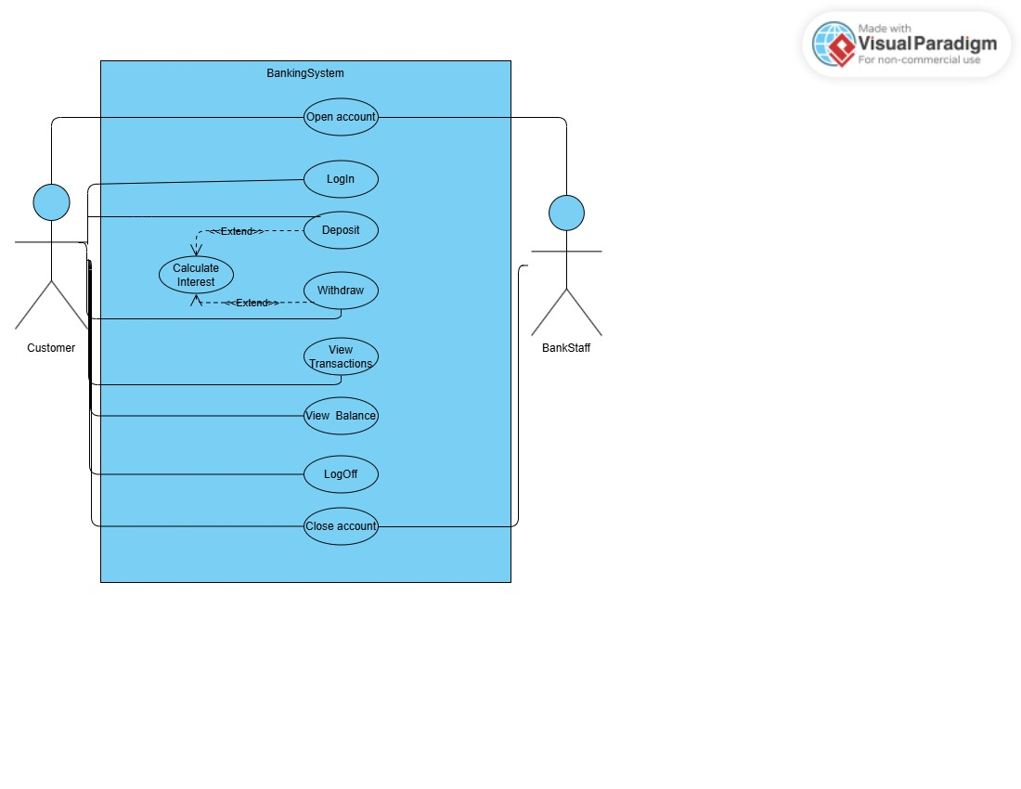

CLASS DIAGRAM

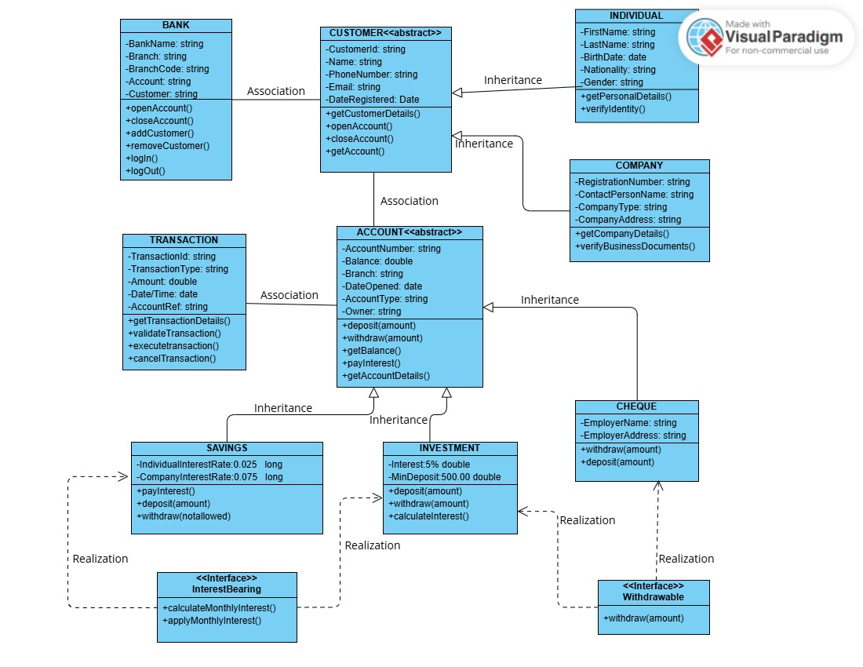

3. BEHAVIOURAL MODELING

LOGIN SEQUENCE DIAGRAM

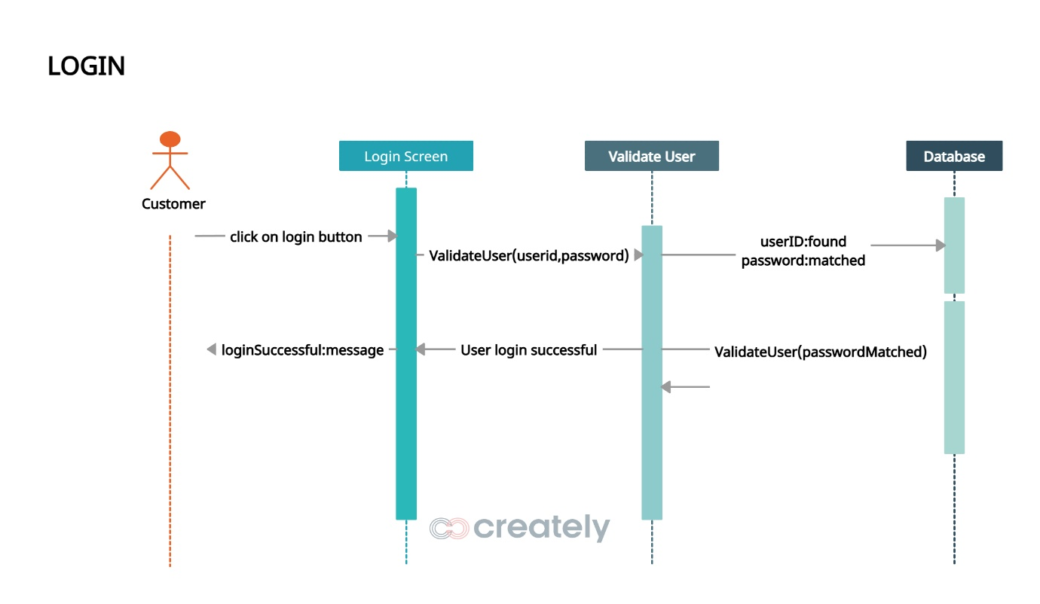

DEPOSIT SEQUENCIAL DIAGRAM

STATE DIAGRAM

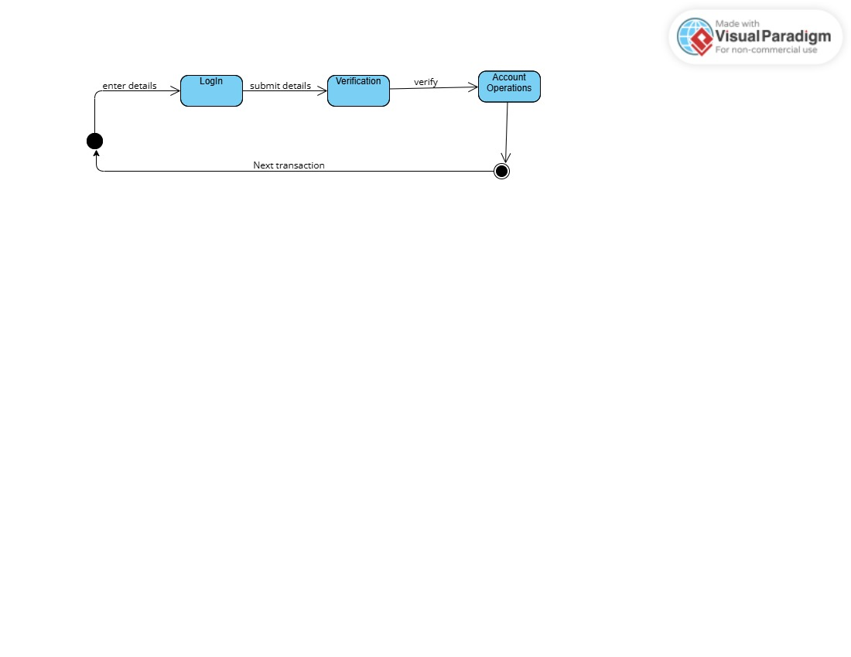

MEETING RECORD APPENDIX

[OOAD Elicitation Session-20250918_103316-Meeting Recording.mp4](https://mybac.sharepoint.com/:v:/s/20252026cse202objectorientedanalysisanddevelopmentwithjav/ETK2KNDOJNNCgI3WOcFy_XUB57nHHAzNSlG9JaieWIF_jg?e=vAD5XB)